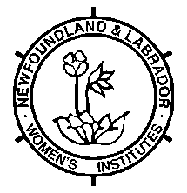 | Provincial Convenors Report  CONVENERSHIP:______________________________  1 copy to NLWI Provincial Office  1 copy to FWIC National Convener  1 copy to be kept for your files

Motto:

Roll Call:

Purpose:

Districts Reporting

[ ] Avalon West
[ ] Central Newfoundland
[ ] Green Bay
[ ] Labrador South
[ ] Notre Dame Bay South
[ ] St. John’s
[ ] Trinity/Bonavista
[ ] West Coast NL

Activities
Avalon West
Projects:.
Special Thanks:
Donations:

Central Newfoundland
Projects:
Special Thanks:
Donations:

Green Bay
Projects:
Special Thanks:
Donations:

Labrador South
Projects:
Special Thanks:.
Donations:

Notre Dame Bay South
Projects:
Special Thanks:.
Donations:

St. John’s
Projects:
Special Thanks:.
Donations:

Trinity and Bonavista
Projects:
Special Thanks:
Donations:

West Coast Newfoundland
Projects:
Special Thanks:
Donations:

